**MongoDB Task**

**attendance**

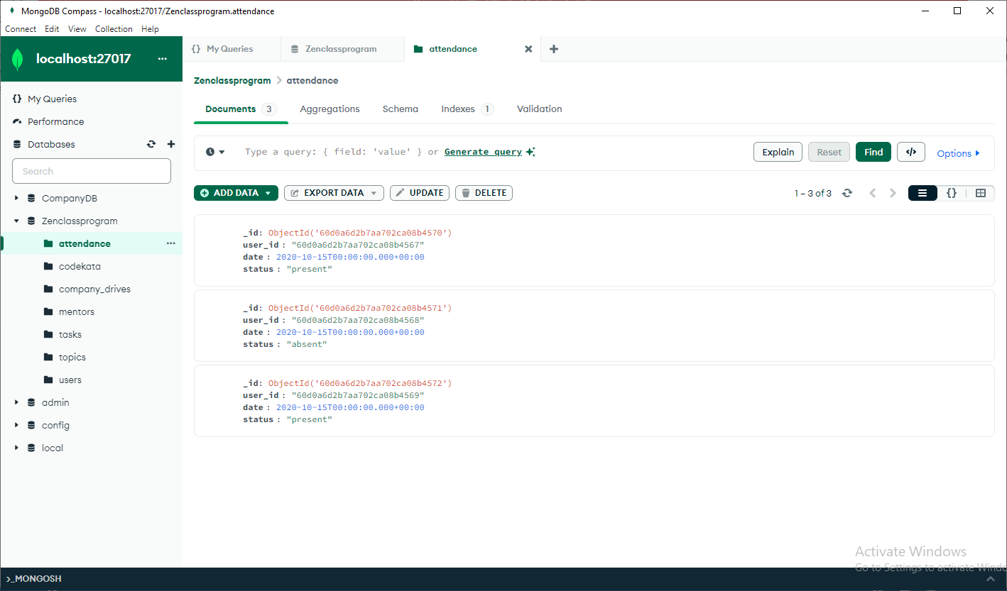

Codekata

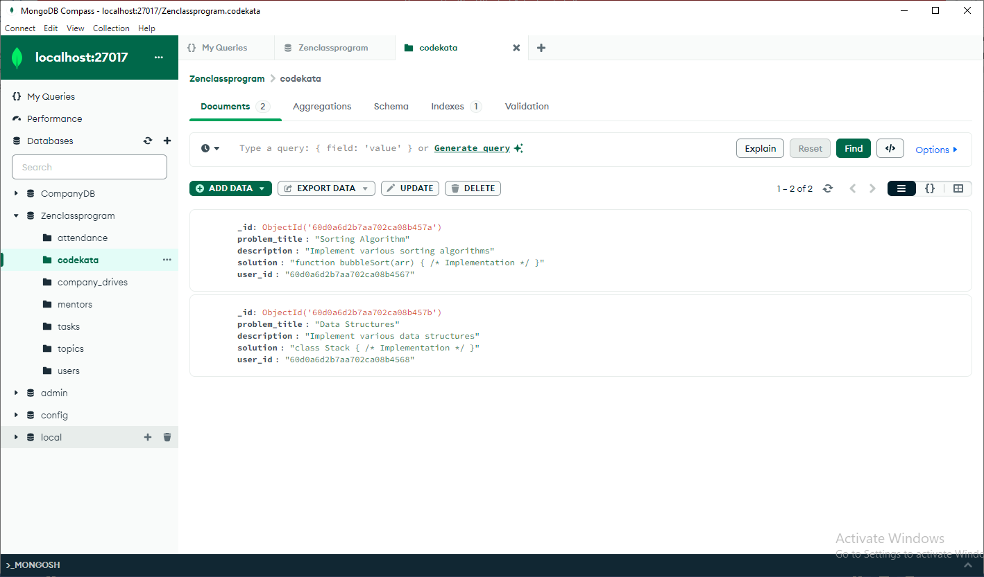

company_drives

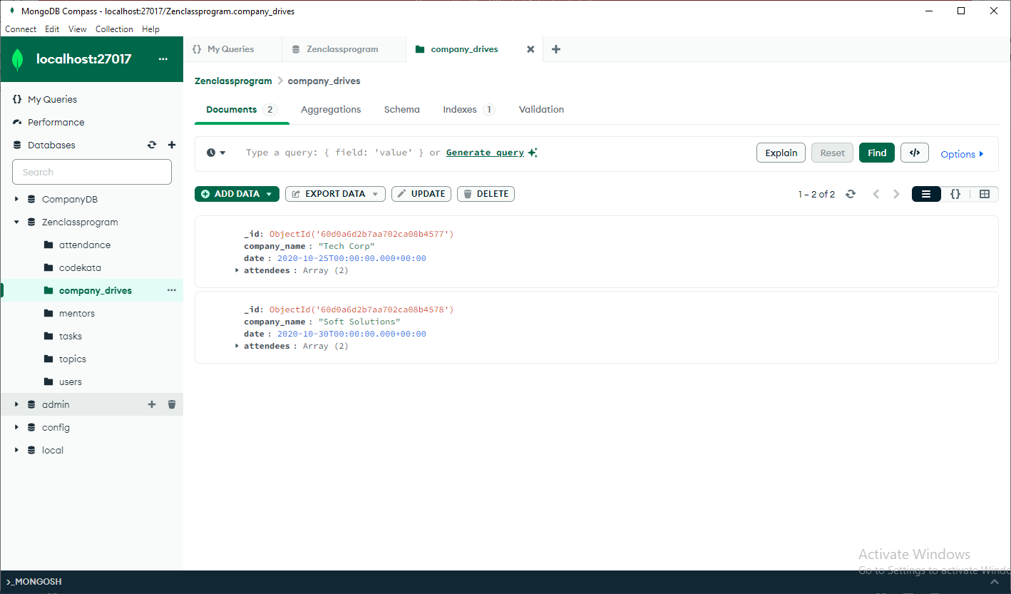

Mentors

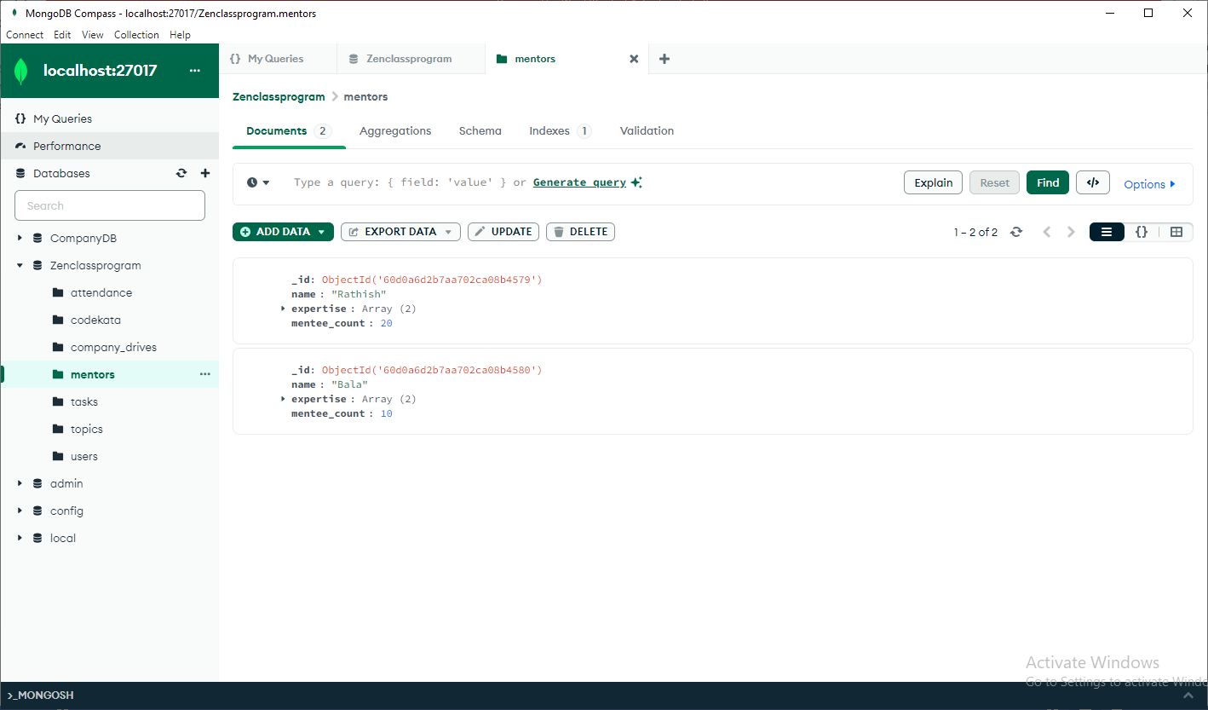

Tasks

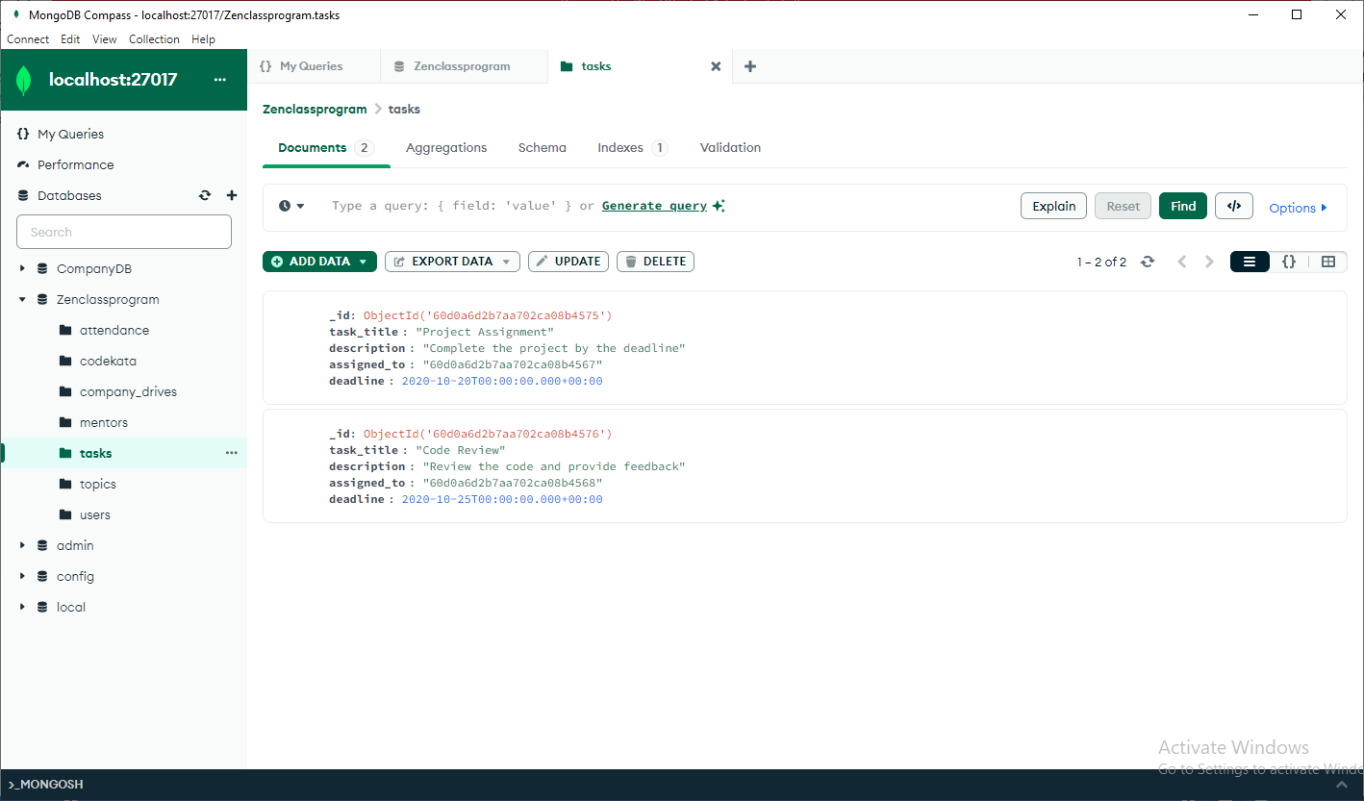

Topics

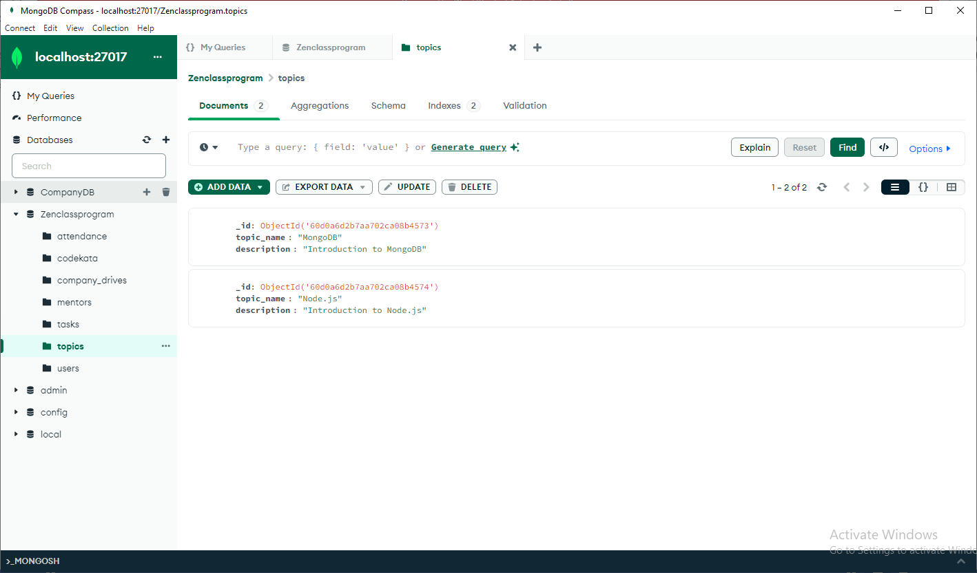

Users

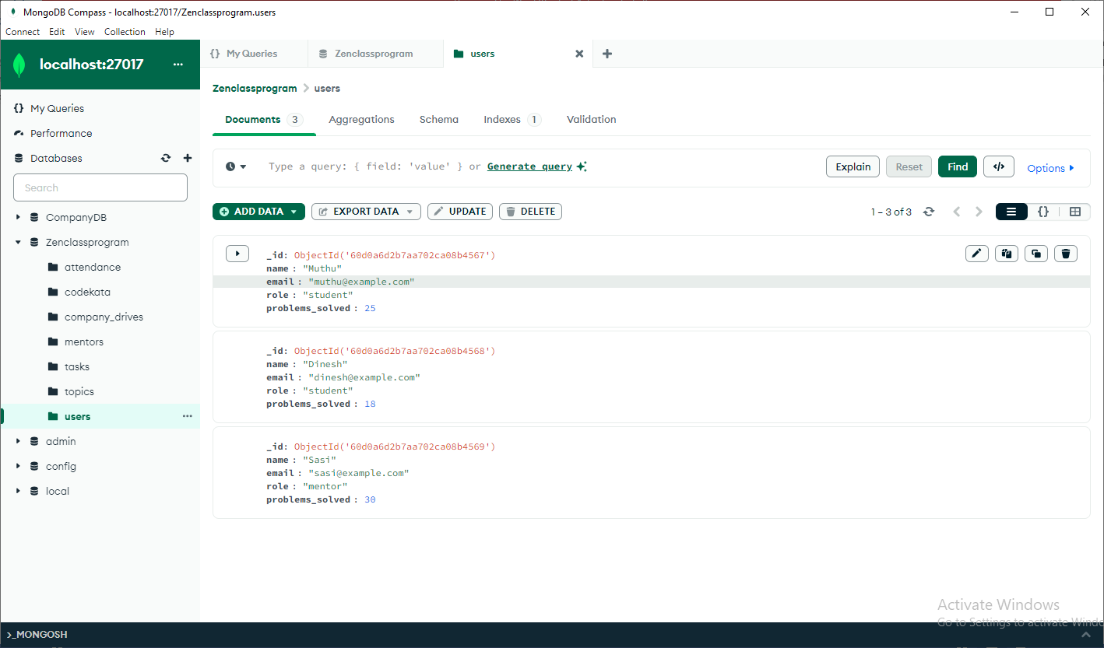

**1:Find all the topics taught in the month of October:**

**Input**: db.topics.find({ "date": { $regex: /^2020-10/ } })

**Output**: { "_id": "60d0a6d2b7aa702ca08b4573", "topic_name": "MongoDB", "description": "Introduction to MongoDB" }

**2:Find all the company drives which appeared between 15th Oct 2020 and 31st Oct 2020:**

**Input**: db.company_drives.find({ "date": { $gte: ISODate("2020-10-15"), $lte: ISODate("2020-10-31") } })

**Output**: { "_id": "60d0a6d2b7aa702ca08b4575", "task_title": "Project Assignment", "description": "Complete the project by the deadline", "assigned_to": "60d0a6d2b7aa702ca08b4567", "deadline": "2020-10-20" }

{ "_id": "60d0a6d2b7aa702ca08b4576", "task_title": "Code Review", "description": "Review the code and provide feedback", "assigned_to": "60d0a6d2b7aa702ca08b4568", "deadline": "2020-10-25" }

**3:Find all the company drives and students who appeared for the placement:**

**Input**: db.company_drives.find({}, { "company_name": 1, "attendees": 1 })

**Output**: { "_id": "60d0a6d2b7aa702ca08b4577", "company_name": "Tech Corp", "attendees": ["60d0a6d2b7aa702ca08b4567", "60d0a6d2b7aa702ca08b4568"] }

{ "_id": "60d0a6d2b7aa702ca08b4578", "company_name": "Soft Solutions", "attendees": ["60d0a6d2b7aa702ca08b4567", "60d0a6d2b7aa702ca08b4569"] }

**4:Find the number of problems solved by the user in codekata:**

**Input**: db.users.find({ "role": "student" }).forEach(function(student) {

print(student.name + " solved " + student.problems_solved + " problems.");

});

**Output**: Muthu solved 25 problems.

Dinesh solved 18 problems.

**5:Find all the mentors with mentee count more than 15:**

**Input**: db.mentors.find({ "mentee_count": { $gt: 15 } })

**Output**: { "_id": "60d0a6d2b7aa702ca08b4579", "name": "Alice", "expertise": ["Web Development", "JavaScript"], "mentee_count": 20 }

**6:Find the number of users who are absent and task is not submitted between 15th Oct 2020 and 31st Oct 2020:**

**Input**: db.attendance.aggregate([

{ $match: { "date": { $gte: ISODate("2020-10-15"), $lte: ISODate("2020-10-31") }, "status": "absent" } },

{

$lookup: {

from: "tasks",

localField: "user_id",

foreignField: "assigned_to",

as: "task"

}

},

{ $match: { "task": [] } },

{ $count: "absent_users_with_no_task" }

])

**Output**: { "absent_users_with_no_task": 1 }